Prithwi Secondary Boarding School

Final–Term exam

Class: L.K.G F:M=50

Subject: English P:M=20

Name: …………………………………………………………………

Q.NO.1. Match the small letter with capital letter. [6]

K u

U k

W p

P w

V r

R v

Q.NO.2. Write down the missing letters. [8]

1. A …… t

2. B ……… l l

3. D o …… l

4. E g …….

5. K …… n g

6. J ……. m

7. K i ….. e

8. L a …… p

Q.NO.3. Write one and many. [6]

One Many

1. Pen
2. Cup
3. Pencil
4. Apple
5. Cat
6. Tree

Q.NO.4. Write the missing vowel letters. [8]

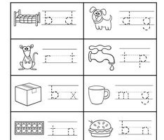

Q.NO.5. Use article a and an. [10]

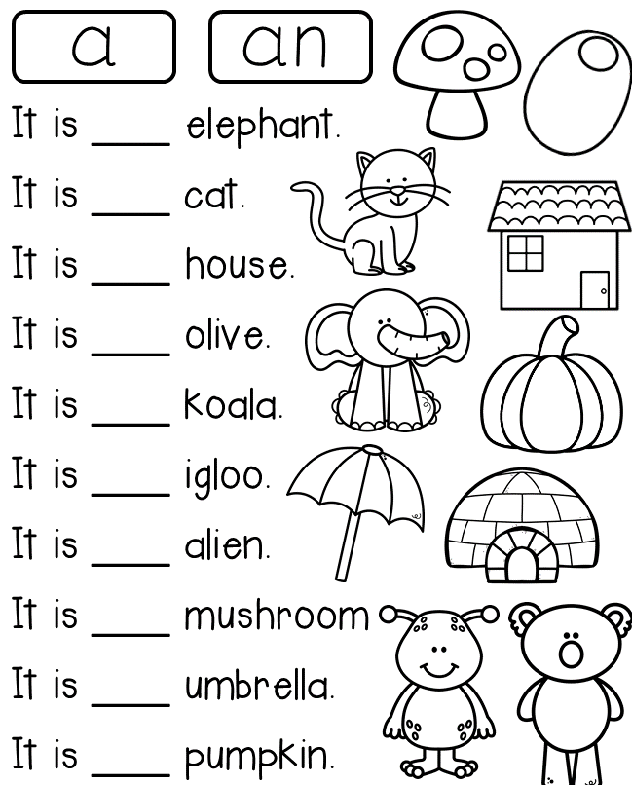

Q.NO.6. Look at the picture and write he or she. [8]

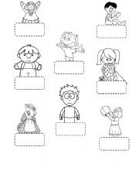

Q.NO.7. Match with starting letter word. [4]

